**AI-Powered NGO Donation & Impact Management System**

**Industry: Non-Profit / Social Services**

**Project Type: B2C Salesforce CRM Implementation with AI & Automation**

**Target Users: NGO Teams, Donors, Volunteers, Campaign Managers**

**Problem Statement**

Many Non-Governmental Organizations (NGOs) still rely on spreadsheets, emails, and manual registers to manage donors, track donations, and run campaigns. This results in:

* **Missed or untracked donations** – leading to revenue loss
* **Duplicate donor records** – causing data inconsistency and confusion
* **No automated follow-up or acknowledgment** – weakening donor relationships
* **Difficulty in showing donation utilization** – reducing donor trust
* **Lack of real-time reports** – making decision-making slow and reactive

To address these challenges, the NGO plans to implement a Salesforce-based NGO & Donation Management CRM, which will:

* **Centralize donor data** in one system for accuracy and easy access
* **Track donations** and auto-generate receipts
* **Send automated thank-you emails/SMS** immediately after donations
* **Manage multiple campaigns** and display progress in real time
* **Provide interactive dashboards** for transparency and data-driven decision

**Use Cases**

1. **Donor Registration & History Tracking:** Register new donors, avoid duplicates, and maintain a complete donation history for each donor.
2. **Donation Tracking & Automated Receipts:** Record donations, update donor totals automatically, and send acknowledgment receipts via email/SMS.
3. **Campaign Creation & Progress Monitoring:** Create fundraising campaigns, monitor funds raised, and view real-time progress on dashboards.
4. **Real-Time Reporting & Insights:** Provide management with dashboards showing donation trends, top donors, and campaign performance for data-driven decisions.

**Business Process Flow:**

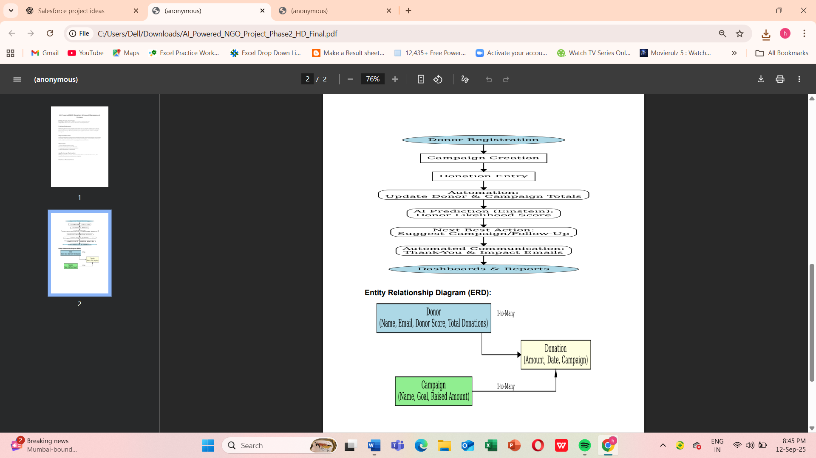

**Entity Relationship Diagram (ERD):**

